September 10, 2019

Meşher: A New Exhibition Space in Istanbul
Inaugural Exhibition

EXHIBITION:
Beyond the Vessel: Myths, Legends, and Fables
in Contemporary Ceramics Around Europe
September 13–December 22, 2019
Meşher, Beyoğlu

Meşher, a new exhibition space initiated by the Vehbi Koç Foundation, opens with its inaugural exhibition Beyond the Vessel: Myths, Legends, and Fables in Contemporary Ceramics around Europe.

Meşher’s first exhibition, Beyond the Vessel: Myths, Legends, and Fables in Contemporary Ceramics Around Europe demonstrates how ancient myths have echoed down through generations, and now form an exciting new wave of contemporary art inspired by the human characteristics and archetypes they represent. It focuses on how clay, often used simply to manufacture vessels and other utilitarian objects, holds the potential of being one of the most refined, yet powerful materials in the hands of artists with exceptional skill and vision, expressing human emotion in the greatest degree of subtlety.

Prepared in collaboration with Messums Wiltshire and co-curated by Catherine Milner and Károly Aliotti, the exhibition presents works by 13 artists, each of whom, in their distinctive way, shows the enduring potency of historic narratives manifested in the material of clay. Meşher, takes its name from the Ottoman Turkish word meaning “exhibition space”, and is located in a historic building, which formerly housed Arter at the very center of Istanbul. In the course of the exhibition, Meşher will also organize parallel events, artist talks, and workshops.

Artists
Sam Bakewell, Bertozzi & Casoni, Vivian van Blerk, Christie Brown, Phoebe Cummings, Bouke de Vries, Malene Hartmann Rasmussen, Klara Kristalova, Elsa Sahal, Kim Simonsson, Carolein Smit, Jørgen Haugen Sørensen, Hugo Wilson

Exhibition publication
In conjunction with the opening, Meşher published an exhibition book including articles written by Catherine Milner, the exhibition’s co-curator from Messums Wiltshire, Paul Greenhalgh, Director of Sainsbury Centre for Visual Arts at the University of East Anglia, and Glen R. Brown, Professor of Art History at Kansas State University. Designed by Ayşe Bozkurt, the publication features photographs by Sylvain Deleu and Hadiye Cangökçe.

Meşher
Aiming to establish an interdisciplinary approach, Meşher advocates the creation of new dialogues across time and cultures, not only through its exhibitions but also its comprehensive array of parallel activities such as publications, workshops, and conferences. The exhibitions are mainly conceptualized and produced in-house through a network of collaborations with national and international experts and institutions, thus providing a platform of exchange and inspiration in Turkey and abroad.

Press kit
You can download the press kit which includes the press release and high-resolution images of the selected works from www.mesher.org/press.

Visiting information
Tuesday–Sunday 11.00–19.00
Long Friday 11.00–20.00
Free admission

Meşher on social media
Instagram | YouTube | Spotify

About press images
You can download the hi-res versions of the following press images from www.mesher.org/press
- The captions in this document include the necessary information, including copyright, etc.
- These images can only be used for promotion of this exhibition and all information given here should be used in the relevant media (the collections they belong, if applicable, photographer, etc.)
- The images cannot be cropped, their sizes or colors cannot be changed.

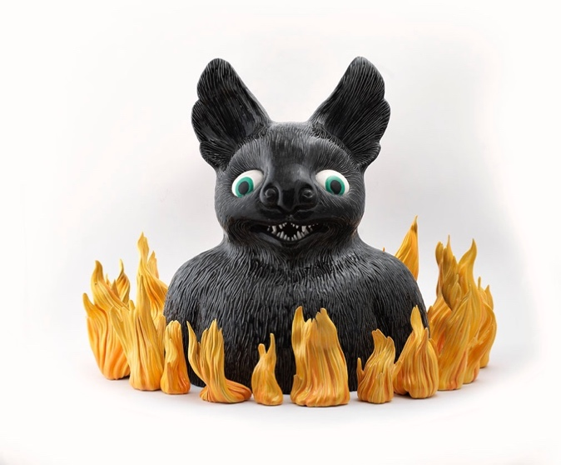
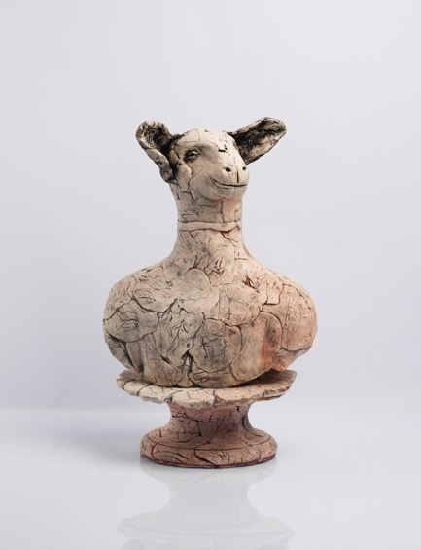
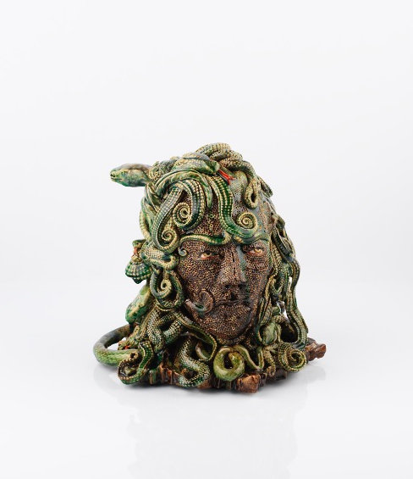
01 Christie Brown  Fancy Sheep, 2019  Ceramic  50 x 32 x 27 cm  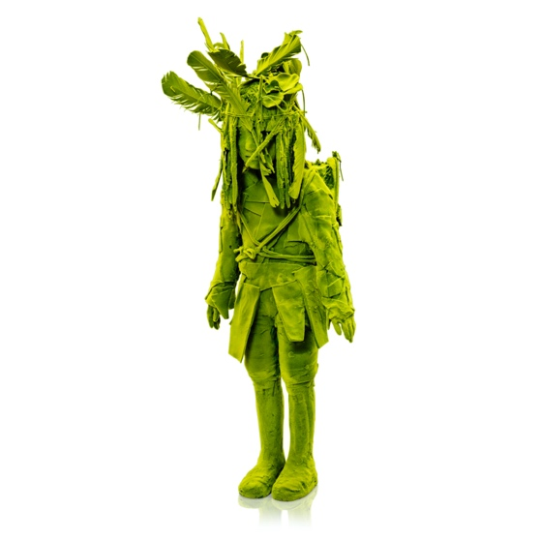 | 02 Malene Hartmann Rasmussen  In the Dead of the Night, 2015  Ceramic  60 x 80 x 56 cm

03 Carolein Smit  Medusa, 2017  Ceramic  27 x 25 x 25 cm | 04 Kim Simonsson  2018  Ceramic, nylon fiber, rope, ready-made  125 x 50 x 50 cm

